Design of Solenoid Engine

City College of New York
Mechanical Engineering Department
ME 462 Manufacturing

Group # 1
Members: Antony Mfitidi, Alaa Barakat, Rodrigo Ulloa, Rezwan Islam, Juan Vasquez, Brian Kalladeen, Lakhvir Singh Sandhar, Michael Sidoo

Introduction
Our chosen manufacturing project was to design a inline solenoid engine using four solenoids. One of the governing engineering principles that gave us the idea for our project was the idea of converting linear motion into rotational motion. This engineering principle is most commonly seen in the internal combustion engine built for automobiles. The concept behind converting the linear motion to rotational motion is seen in that combustion inside the chamber pushes the piston down. The piston is connected by a crankshaft. This component is essential; it allows the conversion of linear motion to rotational motion. This principle is largely what influenced our project. Our group wanted to do something slightly similar but instead of combustion, the main force is generated by magnetism. The solenoids would in theory provide the necessary power to push the piston by harnessing the internal magnetism inside. The main body is made of acrylic. The main shaft is made of carbon fiber material. Further details about the structure and respective components will be provided throughout the paper for clarity.
Background
Solenoid engines are at heart electric motors. An electric motor is a mechanical device that switches electric energy into mechanical energy by passing an electric current through a wire loop contained within a magnetic field. Furthermore, a solenoid is a coil of conductive wire that is able to produce a magnetic field thanks to the electric current generated in the coil. There are types of solenoids for which there’s a movable iron or steel core. When current flows through the wire, a magnetic field gathers around it. Thus when the current flows through the wire the magnetic force created provides movement within that path, usually in a linear motion. The movable core within the solenoid then moves to close the air gaps between each coil to create flux linkage as the coil energizes. This movement is usually reversed by a spring attached to a mounting backplate for support to push down the core/plunger back to its original position once the current turns off. Since solenoids are inexpensive, their use in daily life is extensive in appliances, automobiles, office products, machines etc.
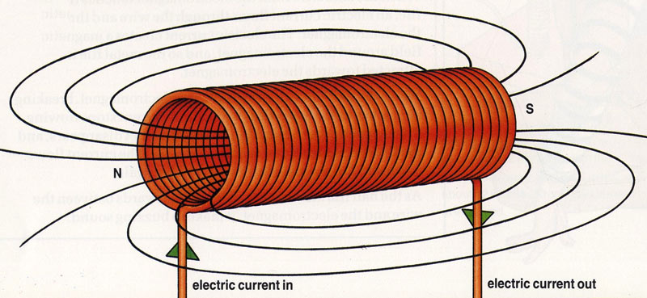
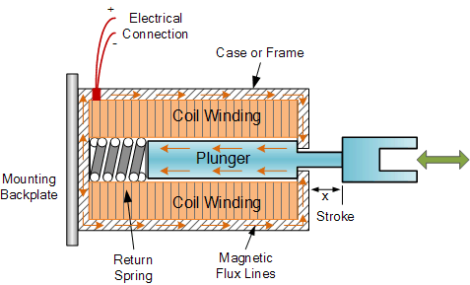
Calculations Prior to Modelling
During the design phase of the project, we called the following parameters in order to obtain the necessary force needed to lift up the piston
- Steel rod: relative permeability (u_r = 100)
- Permeability in a vaccum (u_0 = 4*pi*10^-7)
- Magnet or enamel (gamma) wire: Resistance per meter = 0.214 ohms/m
- Number of turns (N = 200)
- Voltage from battery (V = 22 V)
- Amps (I = 30 A)
- Solenoid length (l = 60 mm)
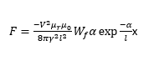
The equation used to determined the solenoid is:
Where W_f is the winding factor and alpha is the natural log of the relative permeability. Having around 200 turns of the type of wire is equivalent of having five millimeter thickness of wire around the plastic shaft holding the wire.
Modelling in Solidworks
In order to see how our completed part would look like and to see if our calculations were feasible, we used Solidworks to create a model, and then later on used the SolidWorks HSM software to create the toolpath for the CNC machine.
Prior Testing and Observations
Upon deciding to use solenoids for our project we wanted to see a proof of concept before we went full scale and ordered our parts and started manufacturing. The idea was simple, wrap a wire around a hollow cylindrical body and apply a current through that coil to make a magnetic field and pass a metal rod (acts as a piston) through that magnetic field to create linear motion. The first prototype that we made was a solenoid made from a pen tube and spare wire that we had. We wrapped about 100 turn around the pen tube and used a steel nail to act as the piston (not shown because is was lost or stolen). Once we saw that it worked we wanted to use something that was more like what we would actually use for the solenoid housing so we created another solenoid, this time using a piece of spare plastic tubing to ensure it would work.
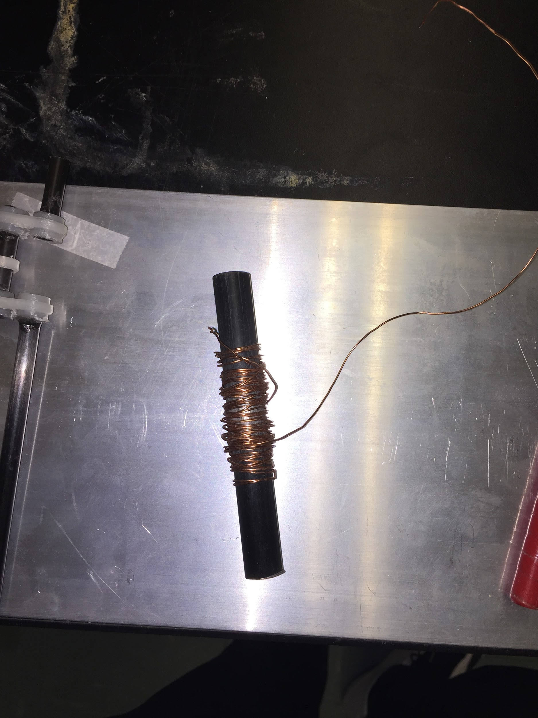
In order to make sure we were on the right track and our calculated dimensions were correct, we first cut one piston housing and steel piston tube. Our first test had 100 coils of the magnetic wire wrapped around the piston housing and was not insulated. A 9 volt battery was connected by having one end of the coil fixed in the negative side of the battery and the positive side of the battery connected fleetingly using the other end of the wire. We found that the battery increased in temperature at an alarming rate. While the piston moved whenever the connection was set, the heat of the moving current in the coil deformed the piston housing. Therefore we knew that the wire had to insulated and have increased number of turns in order to keep the temperature below the limit of the piston housing. The next testing was using the same number of piston and piston housing. This time we wrapped a double wrapping of the housing using electrical tape and increased the number of coils to 200. Battery connection was the same as before. We found that the increased number of coils and insulation via electrical tape produced the same movement of the piston without the battery heating up and no deformation of the housing. However we still wanted to produce the best possible result and continued two further tests with the same voltage applied and same number electric tape wraps. The former option had 300 coils running the length while the second had 300 coils concentrated near the base. We observed that the former with 300 coils running the length produced a slower pulling reaction of the piston shaft meaning the resistance was more stronger that resisted an increase in temperature but was not ideal since we required a certain factor of speed. The latter option with the coils concentrated at the bottom did not lift the piston shaft fully indicating that the magnetic field most likely had a smaller magnitude of length so its effect was not effective.
After observing all these tests, we ultimately chose the double wrapping of electric tape with 200 coils running its length since it produce the best outputs such as resistance to heat and strong magnetic field to lift the piston shaft effectively.
Procedure: Modeling on Solidworks
Several parts were modeled in solidworks before the model was manufactured. In order to test if the dimensions were correct a basic motion study was done to make sure that all the dimensions were correct.
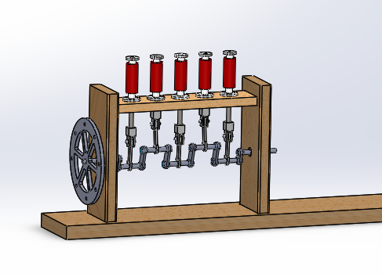
Materials/Cost
Since our allotted budget for the project was $175, we decided that we would use relatively inexpensive materials, that would still be strong enough when utilized. In addition, many of our smaller parts such as piston and crankshaft connections were to be 3D printed in the manufacturing lab using filament. As a group, we decided on having an acrylic base and frame, with piston housings. We also used magnetic wire for its higher heat resistance and absorption and electric tape for the piston housing. In addition, we used nano carbon tube for the crankshaft and a steel tube for the solenoid movable core, or the piston itself. These materials were all bought from McMaster-Carr for a total of $102.41. The table below display the materials used, dimensions, and respective prices.

Manufacturing Supplies
Items | Number of  Units | Unit Cost ($)  - | Total Cost ($)  -
Clear cast acrylic bar (4’’ wide x 3/4‘’ thick, 2ft. long) | 2 | 28.00 | 56.00
Clear cast acrylic bar (3’’wide x 1/2‘’ thick, 2 ft. long) | 1 | 12.14 | 12.14
Clear cast acrylic sheet (6’’ x 12’’ x 1/2‘’) | 1 | 17.49 | 17.49
Clear acrylic round tube (3/8’’ OD x 1/4’’ ID, 6 ft. long) | 2 | 2.73 | 5.46
Clear acrylic round tube (1’’ OD x 7/8’’ ID, 6 ft. long) | 1 | 7.22 | 7.22
Ultra -machinable W1 tool steel (0.25’’ D, 3’ Long) | 1 | 4.10 | 4.10
Total Cost |  |  | 102.41
Procedure: Manufacturing the Project
Being that our group was large enough, we divided the necessary tasks for work within the shop for efficiency and to create a structured timetable to have each individual parts ready by the end of the deadlines. Since the base frame and piston housing of the engine would be made of acrylic, our first step was to cut the acrylic material to the measurements calculated. They were cut using the CNC machine in order to create the most accurate cutting dimensions. To do this, we first opened the models of these part, created on Solidworks, onto the HSM software. From there, we could create the HSM code with toolpaths, intended mills, and necessary operations shown using the HSM library generated in one of our labs. This HSM code was plugged into the CNC machine and it was our responsibility to ensure that the coordinate system in our model matched the real material to be created. Once the coordinate system was entered, we could use the CNC machine to manufacture the part with just mild guiding of the hand cranks or done by the machine completely. The two vertical supports of the frame were connected to the base by first making slots into the base using the CNC machine.
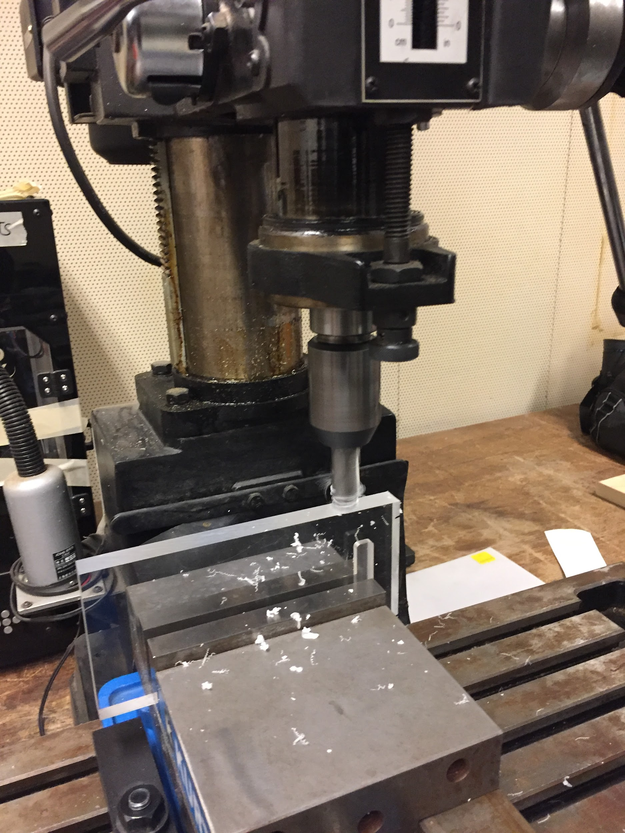
Since the slots were rounded, we sanded down the vertical support ends to fit within the slot and glued with epoxy. The horizontal support of the frame on which the piston housing would rest on was also cut using the CNC machine and connected to the vertical supports by creating slots and gluing with epoxy.
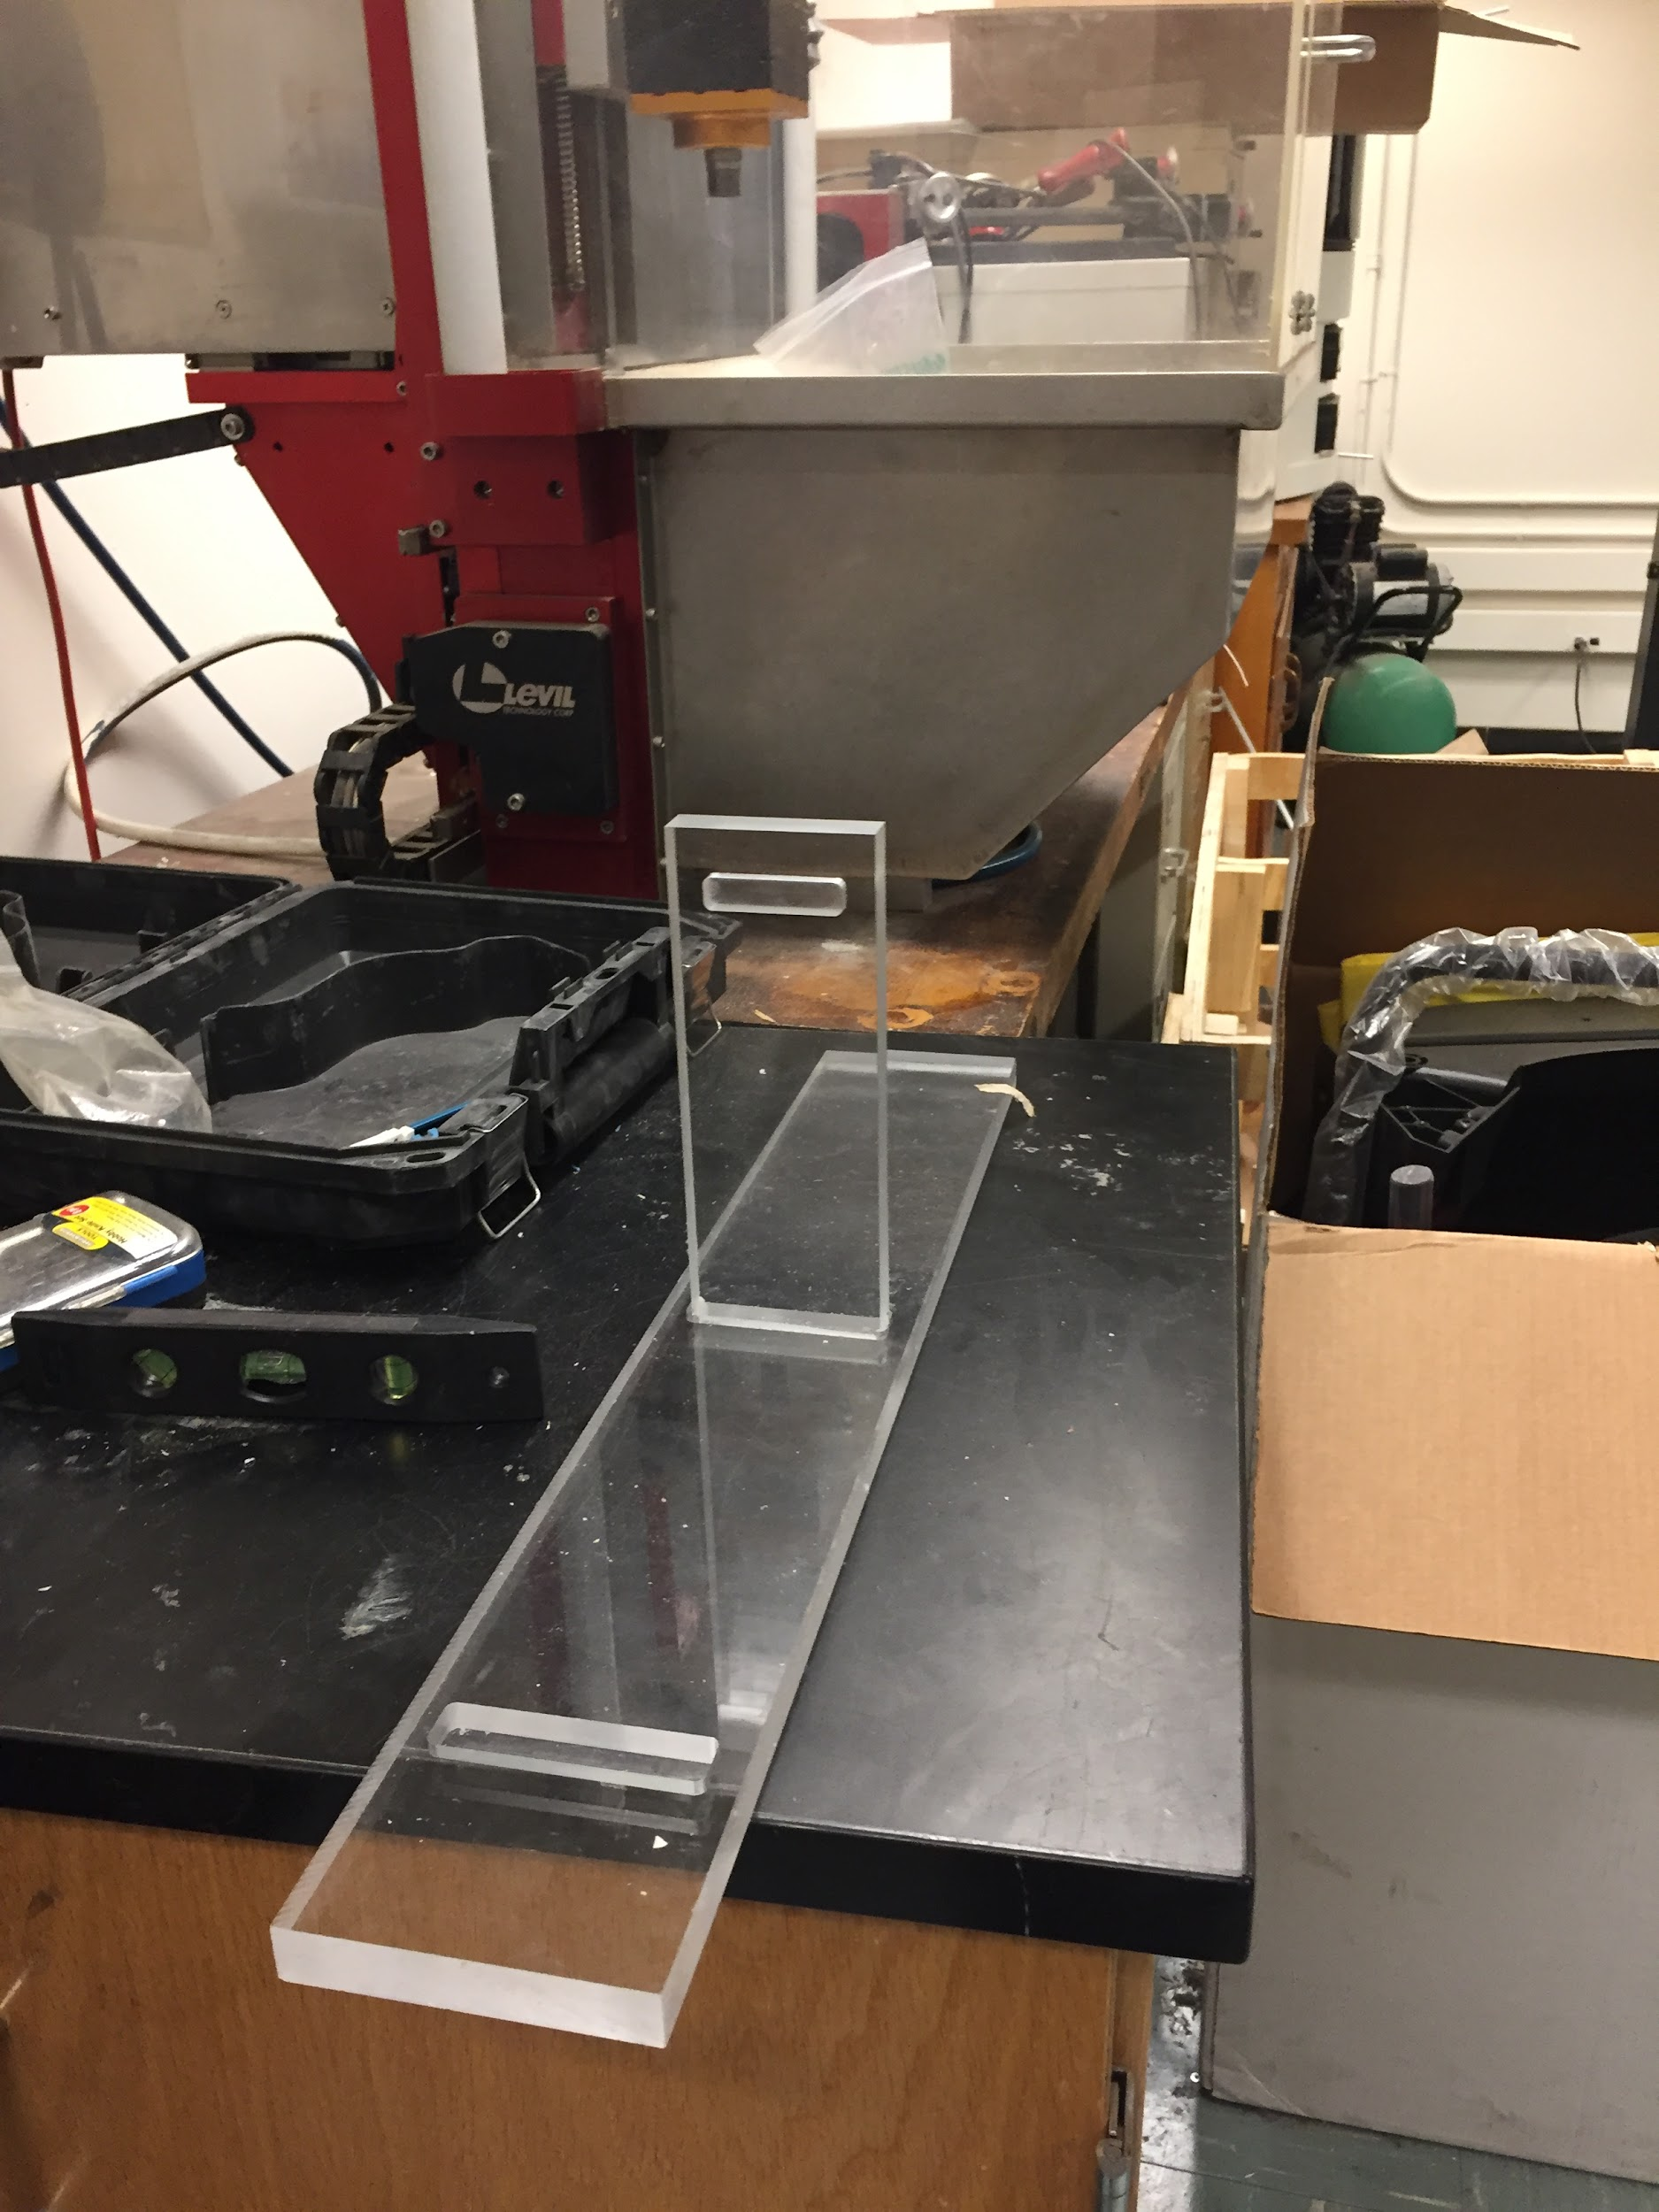
In addition, the holes for the piston housings were also drilled. The piston housings (a total of five) were cut using a bandsaw to saw through the material at the labelled edges. While we were doing these parts, we utilized the 3-D printer to generate the joints and connections necessary, first for testing and then for the actual project. These connections were created first on Solidworks, and then placed on a pallet in a 3-D software and sent as an input to the machine to create these parts using filament.
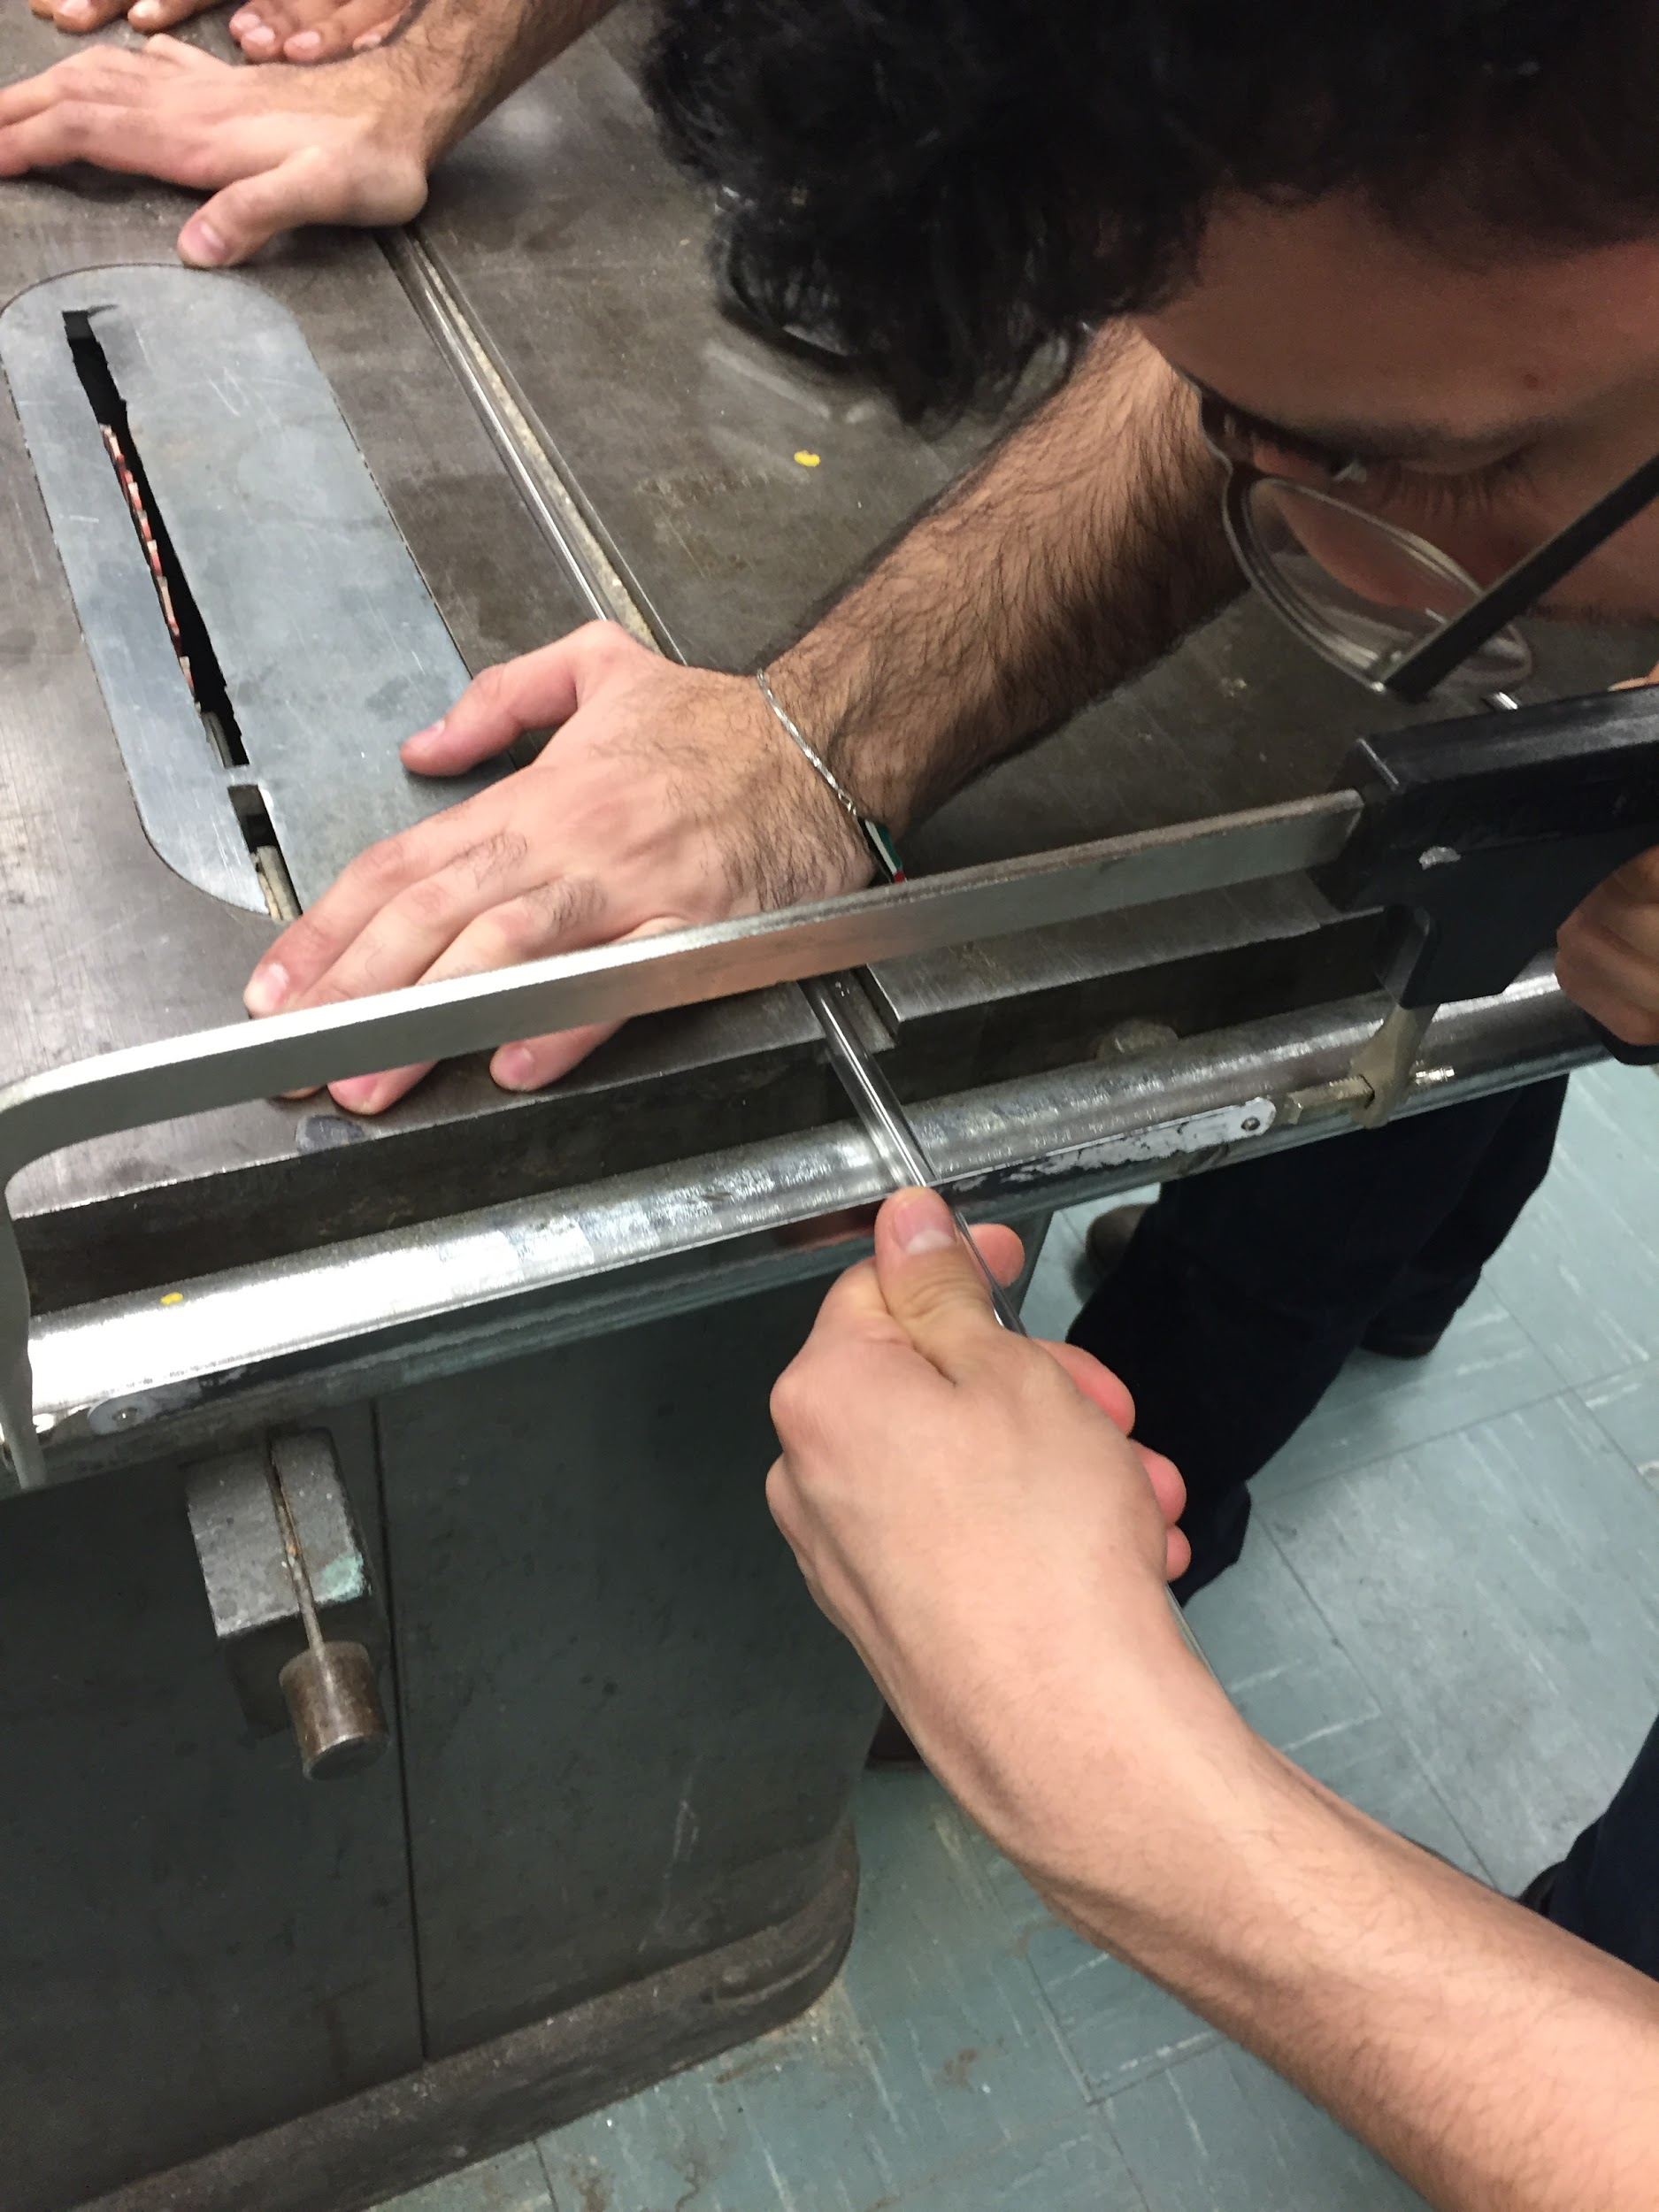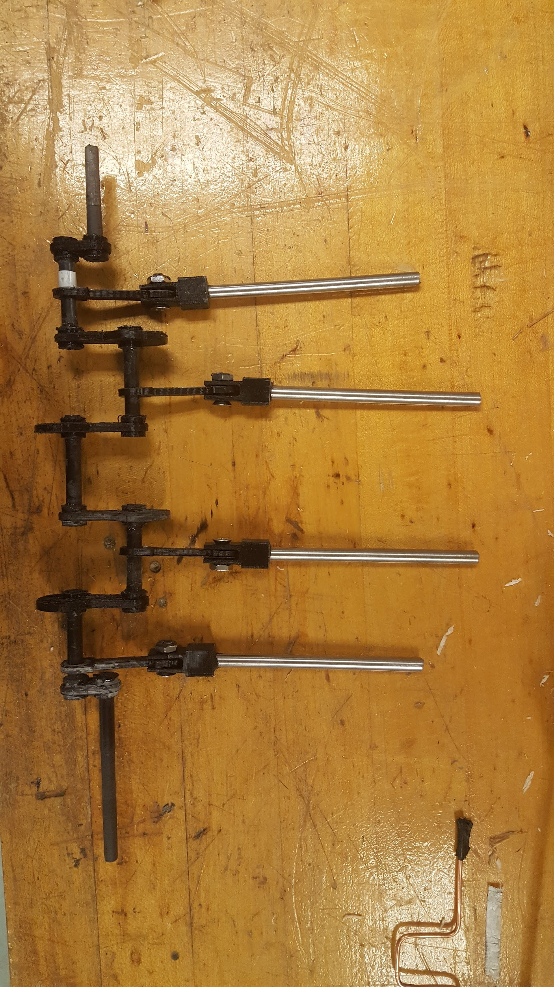
We drilled out the holes in the vertical supports using the CNC machine. Once these holes were drilled, we installed the bearings within the holes. The ends of the carbon nanotube for the crankshaft were first sanded down to fit snugly in the bearings and still allow movement. Then they were cut to the desired number and lengths using a bandsaw. Similarly, the piston rods were also cut using the bandsaw. Since we required a uniform voltage, we required the electrical wires of the solenoids to be connected in parallel. This was accomplished by soldering one wire end from each solenoid into a connecter. The remaining solenoid wire ends were left unsoldered and unconnected since they needed to be connected to the battery.
Now using epoxy resin, we glued the various components of the crankshaft together to create the entire unit. In addition, the piston rod connectors were joined with the crankshaft connectors using nuts and bolts. We left the epoxy overnight to create a complete bond among each component and when we rotated the crankshaft, all the parts rotated effortlessly with minimal friction or sudden surge in rotation.
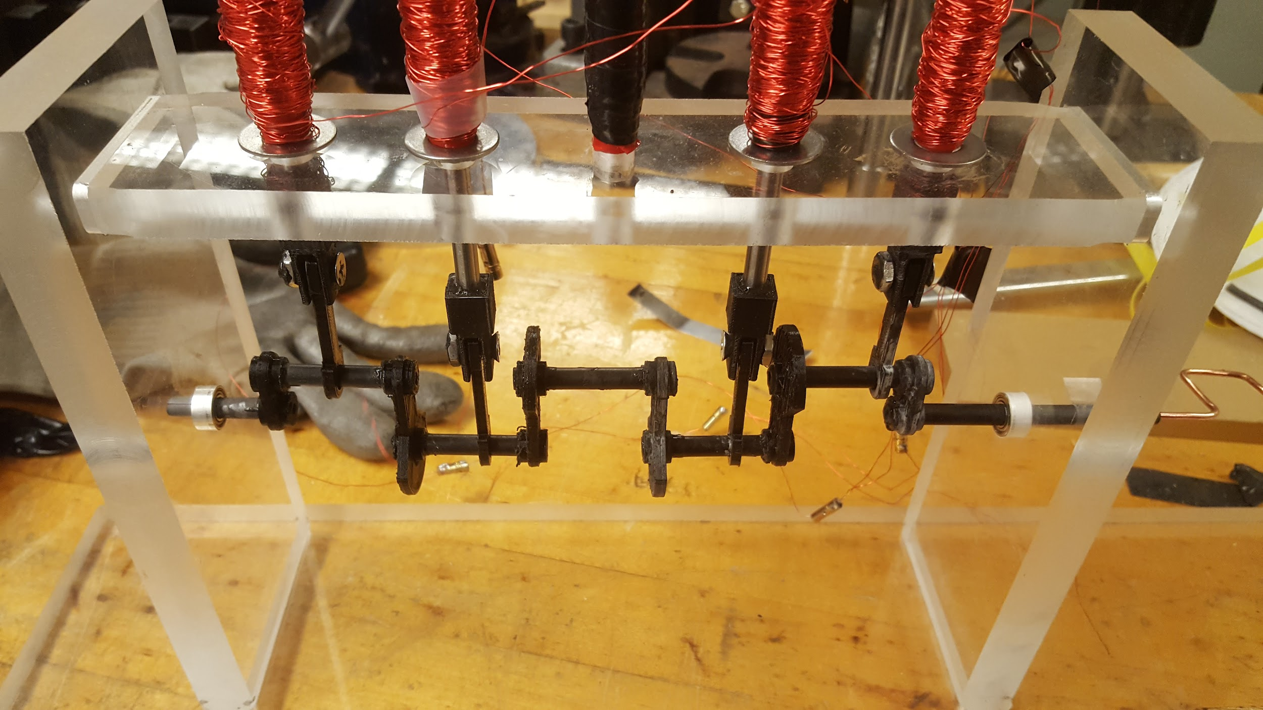
Simultaneously, we manufactured the flywheel using the CNC machine that would attach to the crankshaft and was created on an aluminum plate. This would allow manual movement of the crankshaft while possibly be used to do work.
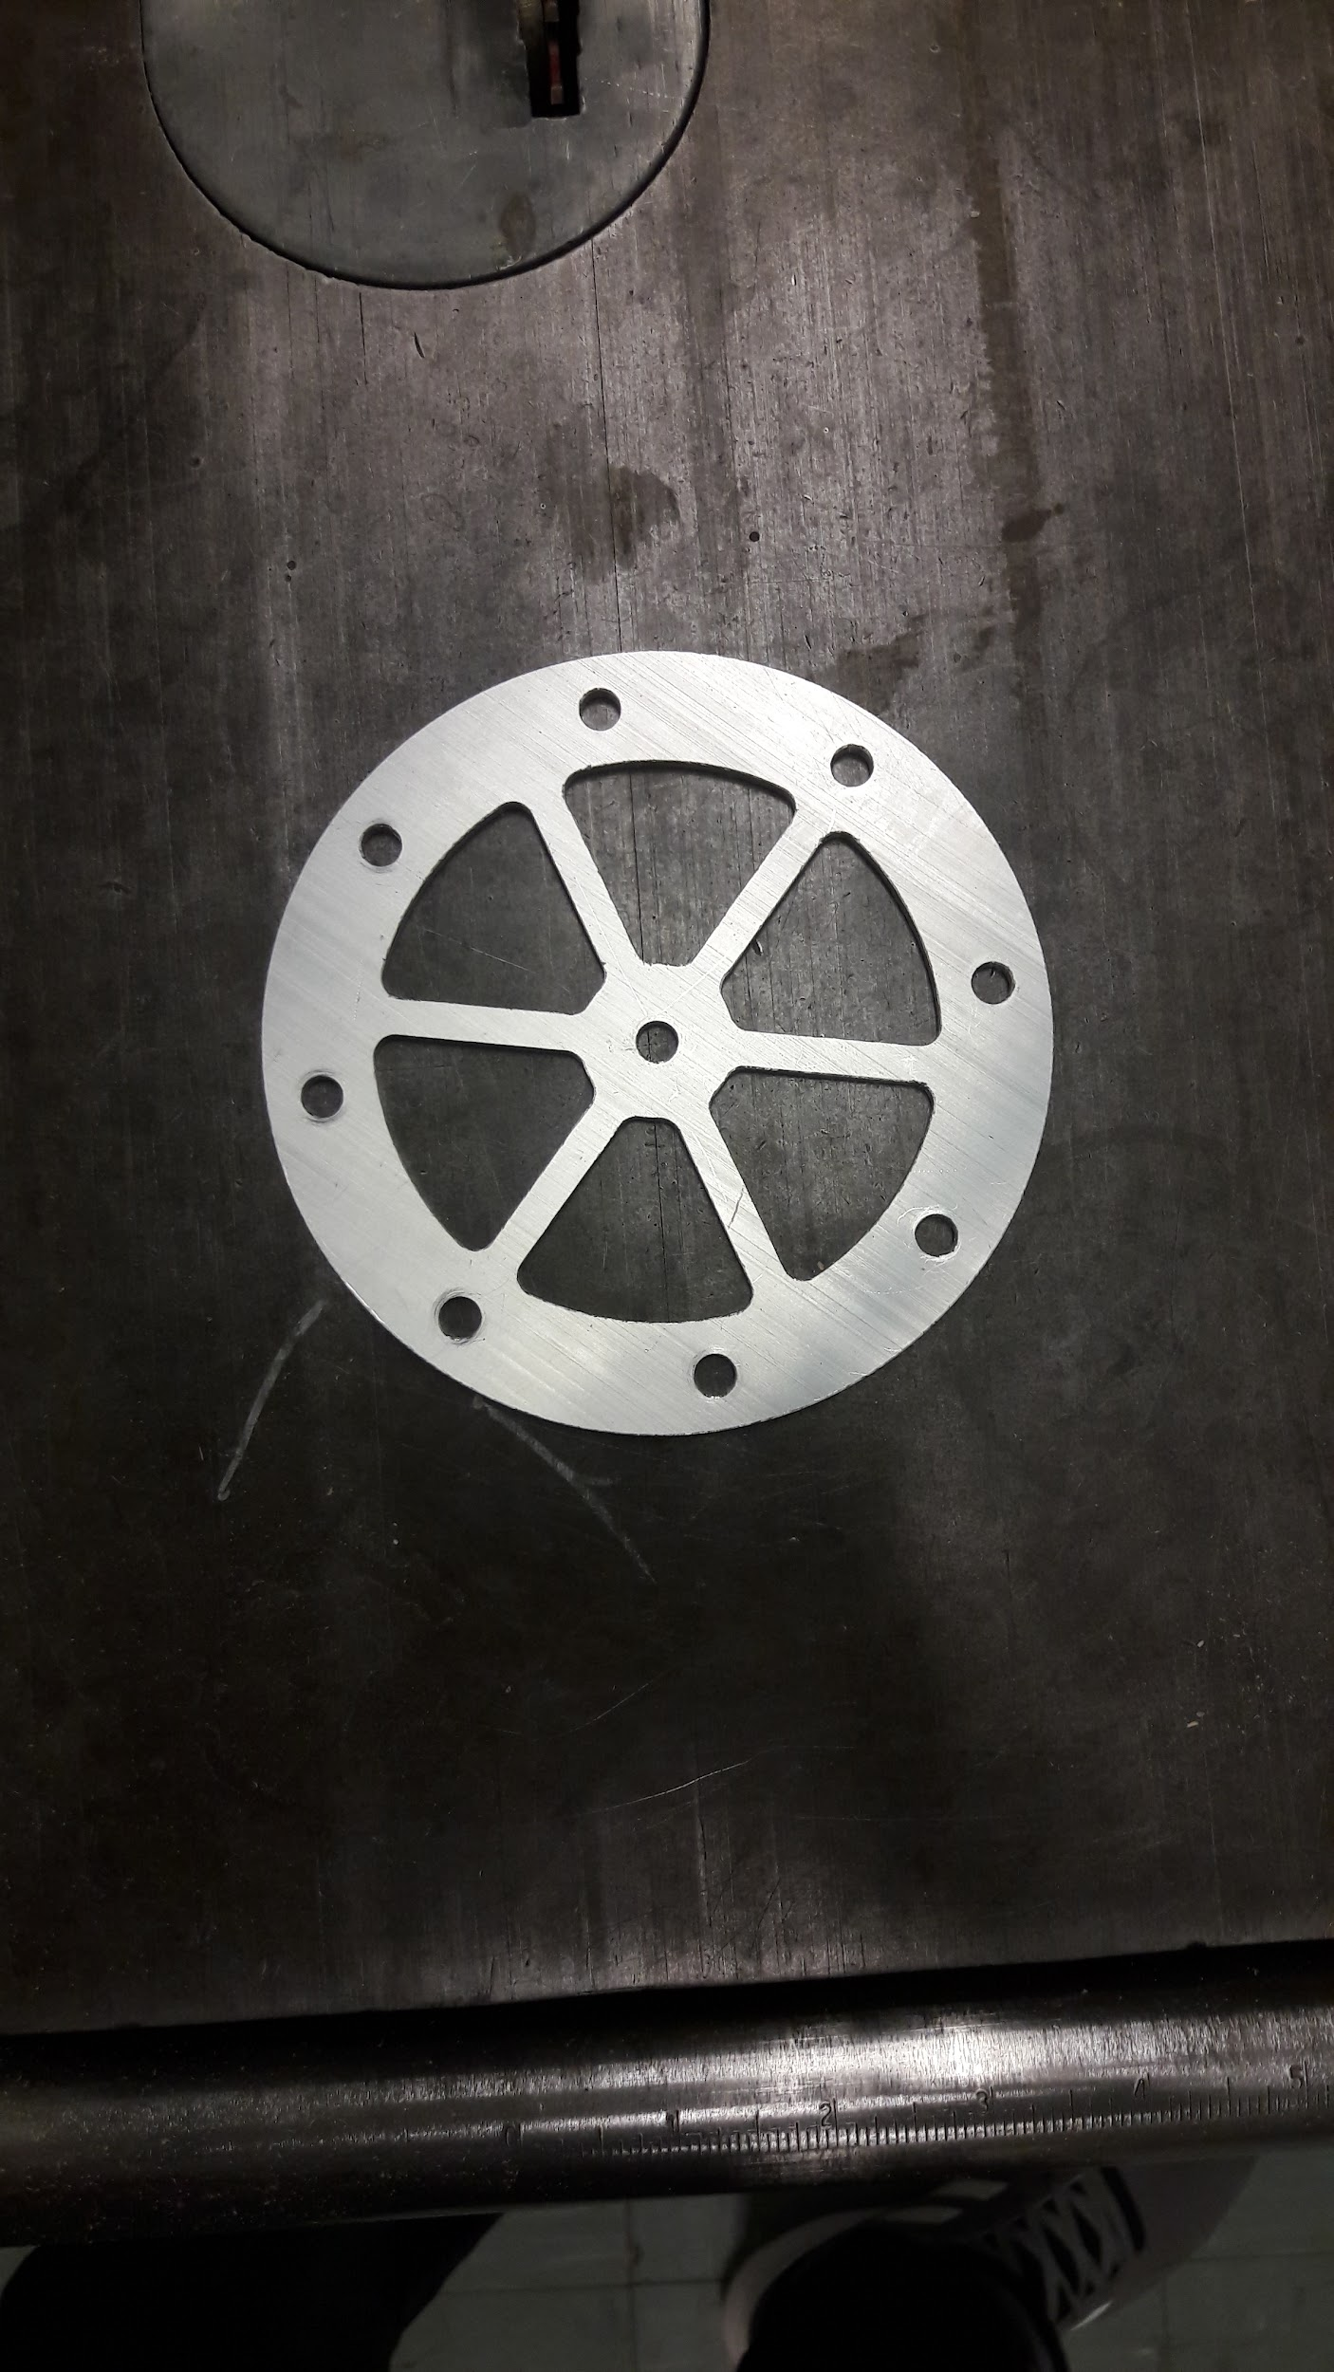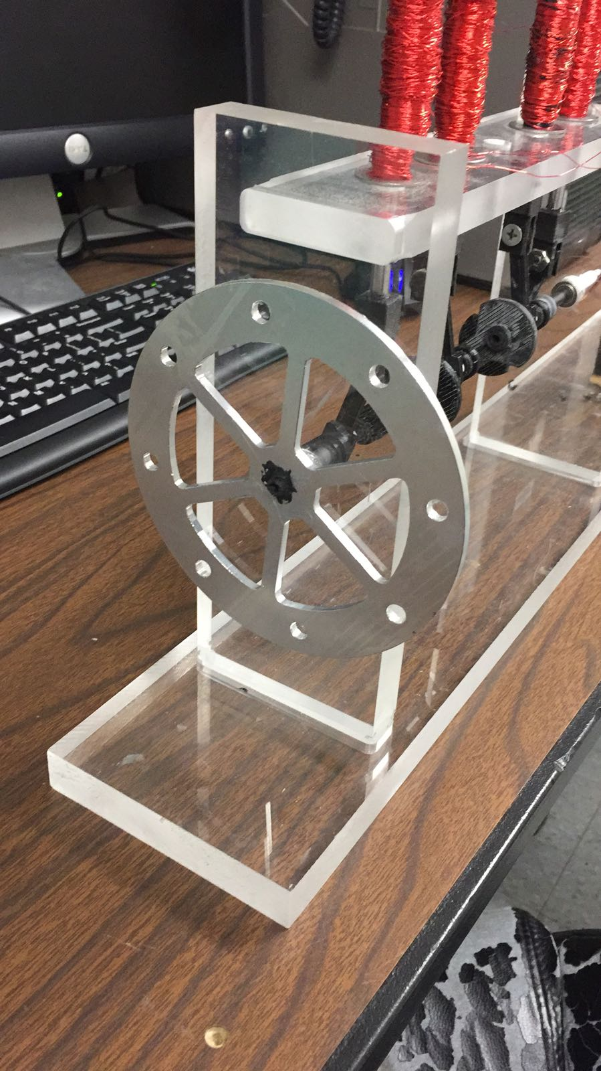
Our last few steps concerned the electrical components necessary for this design. First, we created a copper wire with the necessary number of turns that was attached at one end into the crankshaft. The other end was connected to a vertical support that would allow rotation. This wire would rotate with the crankshaft and strike the aluminum contacts to create a charge. The aluminum contacts were created by cutting two rectangular aluminum pieces and attaching them to the wooden block, connected to the base, by using nuts and bolts. They were also connected on one end to the solenoid wires.
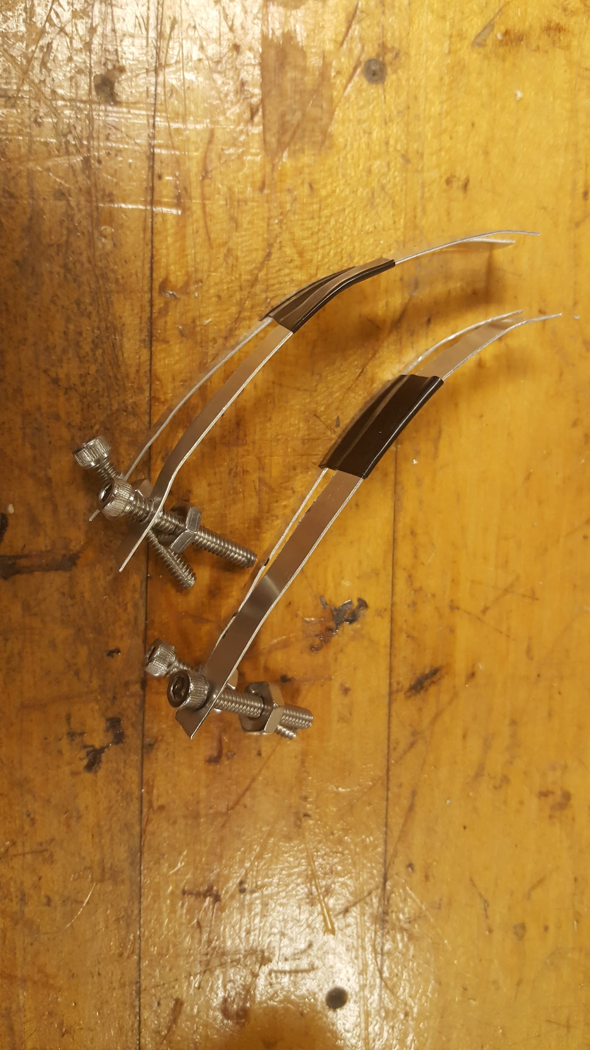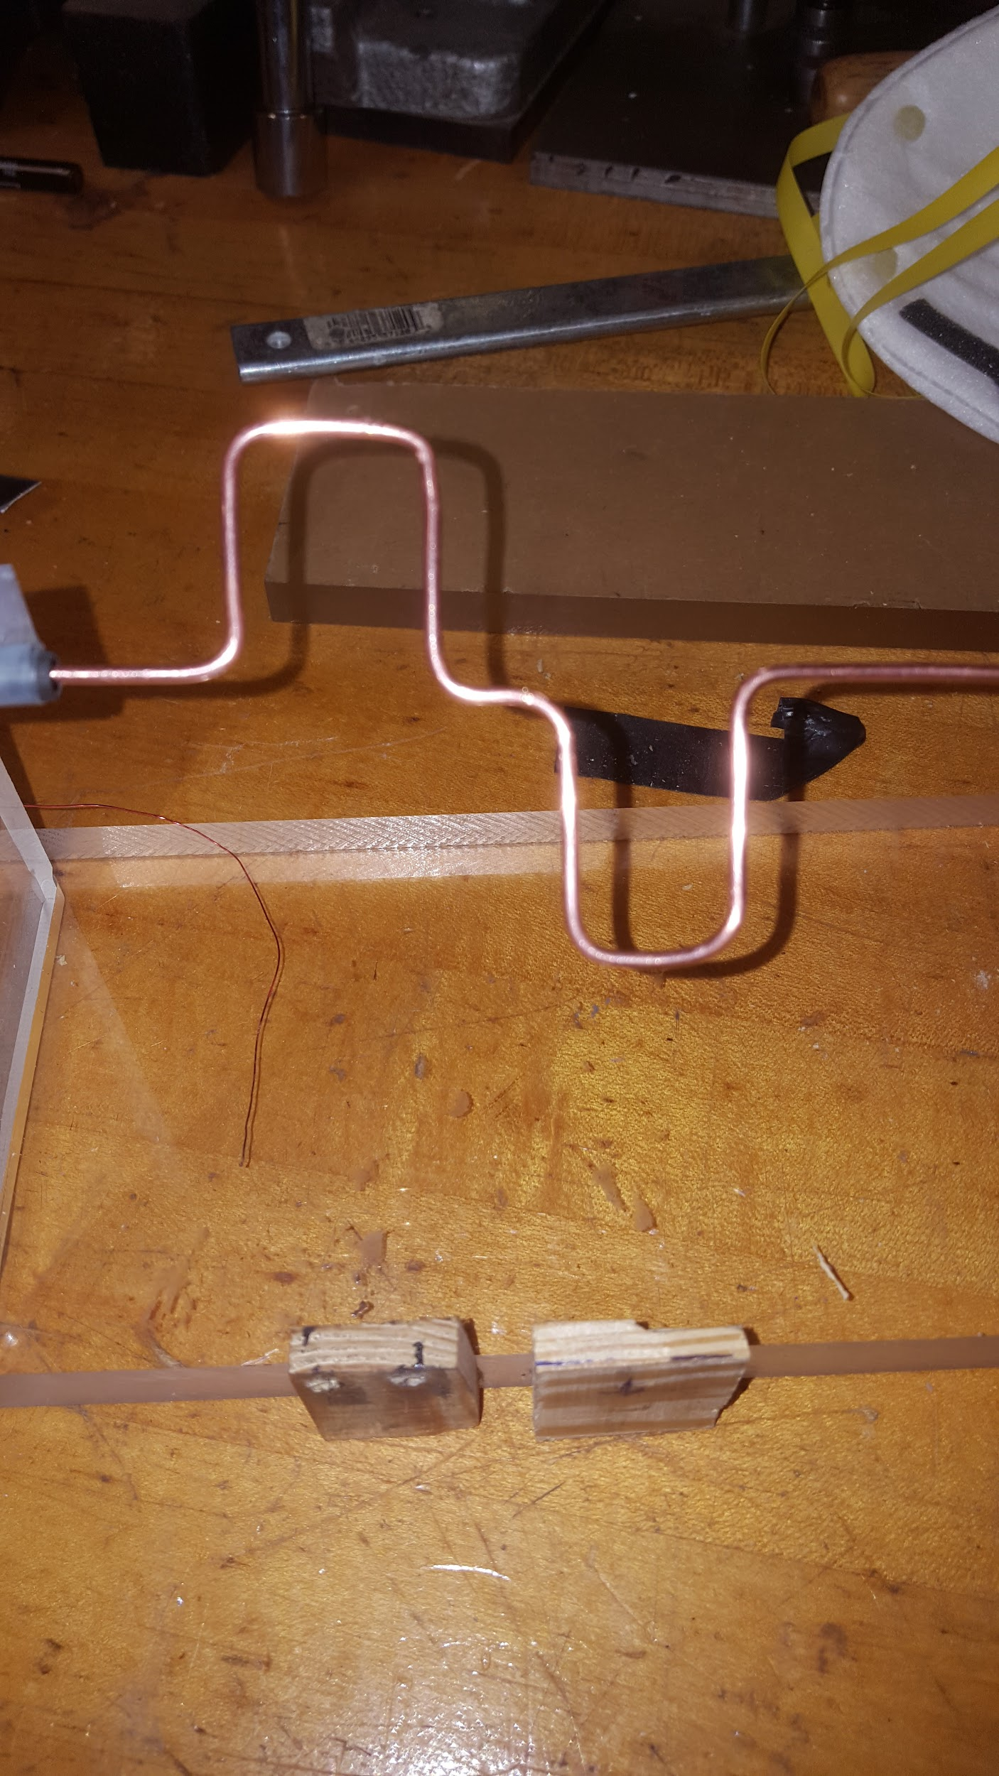
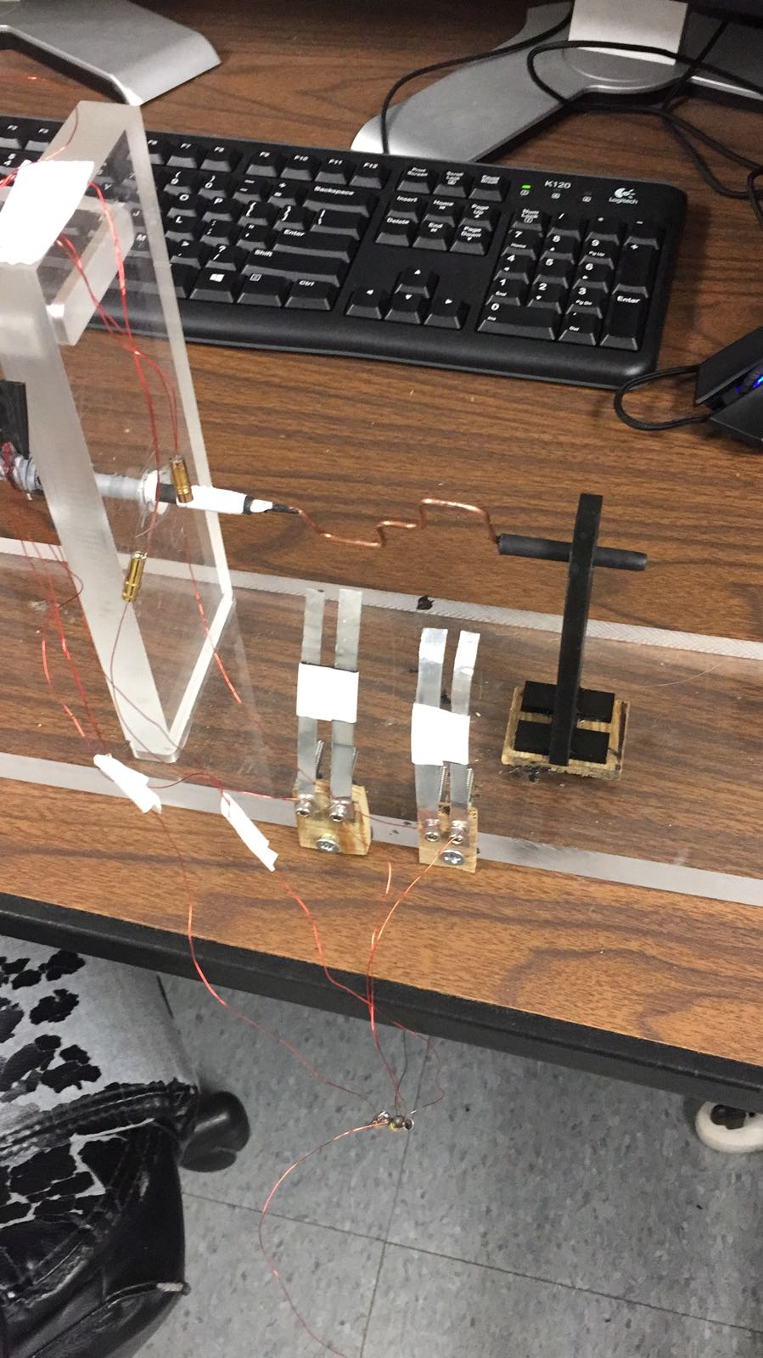
Problems Encountered:
Once we got the material we decided on we wanted to test it out and make sure everything was in working order. We had clear acrylic tubing and a length of steel rod, we cut them to a realistic size that we would use and wrapped the wire around the tubing to create the solenoid. Upon doing this and attaching the battery the coils got too hot and melted the tubing and we had to make some adjustments. We were aware of the heating issue, but we did not think that it would heat up enough to actually melt the tubing. To deal with this heating issue we did two things. First we changed the wire that we were using. At first we were using some spare copper wire that someone gave to us. We tried different gauge copper wire but the heating issue was still there. We then decided to use something more along the lines of what is used in the motor/solenoid industry. We decided to use magnetic copper wire because is had a relatively high resistivity to regular copper wire and it was insulated which contributed to a stronger magnetic field. The other way we dealt with the heating was to wrap electrical tape around the tubing. We tried about 2 or 3 layers of tape and that seemed to do the job in conjunction with the magnetic copper wire but just to be safe on the actual project we used 10 layers of tape.

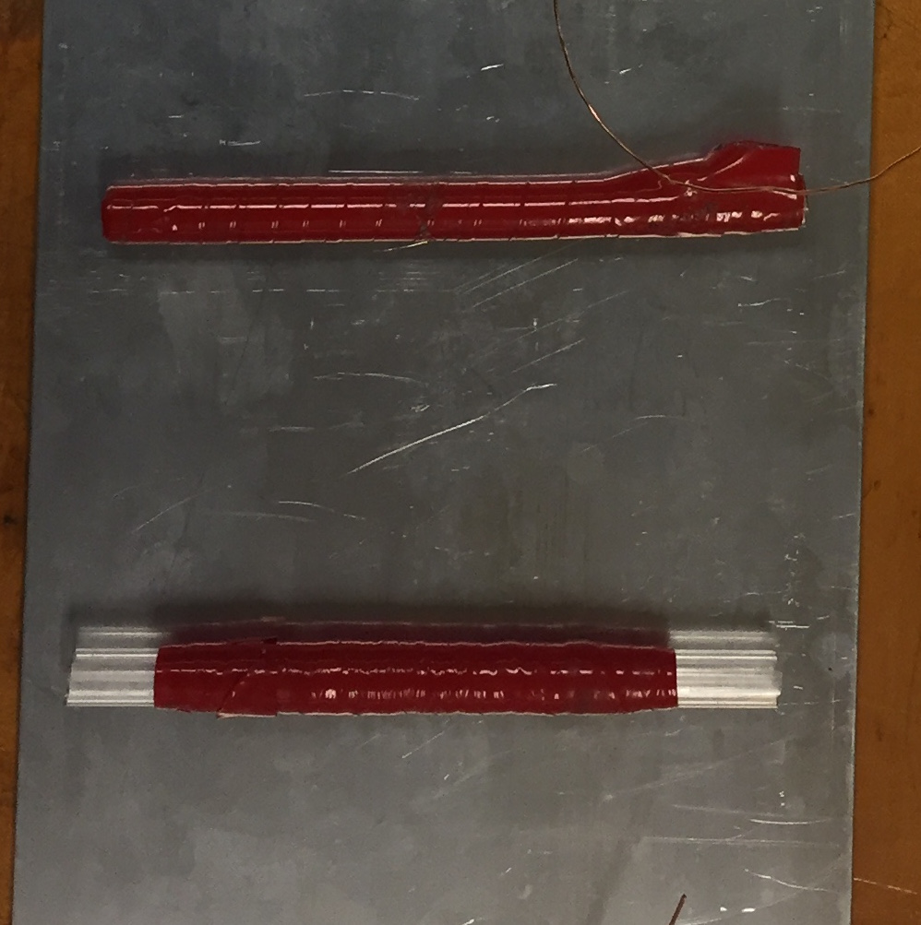

Conclusion
Our manufacturing projects to design a solenoid engine was successful with a number of factors. The first was that we did not exceed the $175 budget, but utilized $102.41thereby saving a total of $72.59. The second factor was that we met our design goals to lower the heat generated by the current flow through the coils and prevented severe deformation by using heat resistant electrical tape as insulation and magnetic wire. Thirdly, all our connections including the crankshaft, copper wire, bearing and piston rods moved fluidly without much friction. In addition, the voltage stayed near constant in the coils and provided enough power to rotate the crankshaft. Lastly, this project was successful in that it helped us to draw on our engineering skills and background to manufacture a project that required us to incorporate our engineering education.
Future Improvements
One improvement would be using the CNC machine to produce the crankshaft components like the pins and the connectors. We could also increase the number of turns of the wire and decrease the current. To produce more powerful and better results, the solenoids could be powered by separate and individual batteries. In addition, the piston rods could be created using magnetic rods rather than steel to produce a faster reaction and stronger pull. Finally, the engine could utilize extra support at middle of crankshaft to minimize deformation and stress due to centrifugal forces.

